Pizza
Classic | 17.99
Toppings | 2.50
Milkshake | 7.50
Single cup/ cone | 5.50
Double cup / cone | 6.75
Toppings | .75
Waffle Cone | 1.50
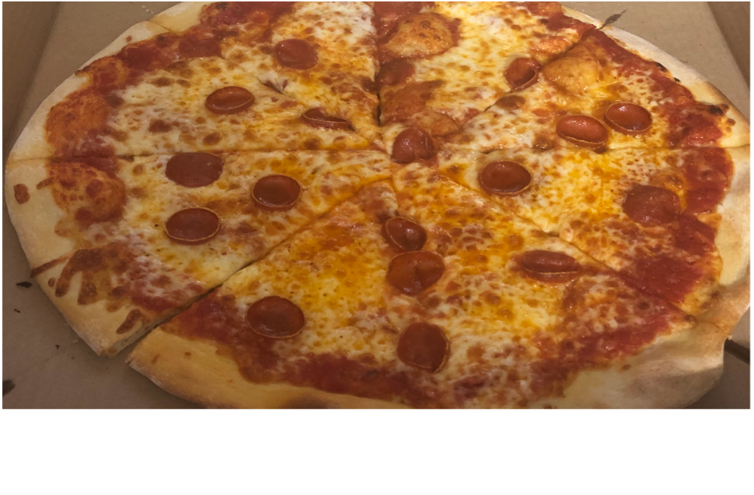

Spicy Pepperoni, Italian Sausage, Onion, Mushroom, Bacon, Ham, Hot / Sweet/ Banana peppers, Extra Cheese

Come check out our new
inventory

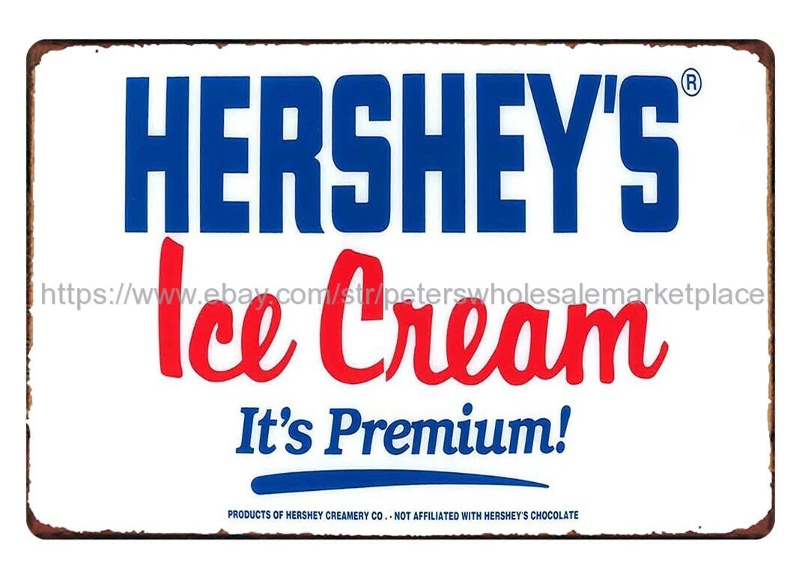
Ice Cream
Toppings
Sprinkles, Rainbow / Chocolate, Whipped Cream, Cherries, M&M’s, Reese’s Pieces, Crushed Oreos, Chocolate Sauce

Prices Subject to change

The Broadkill Store
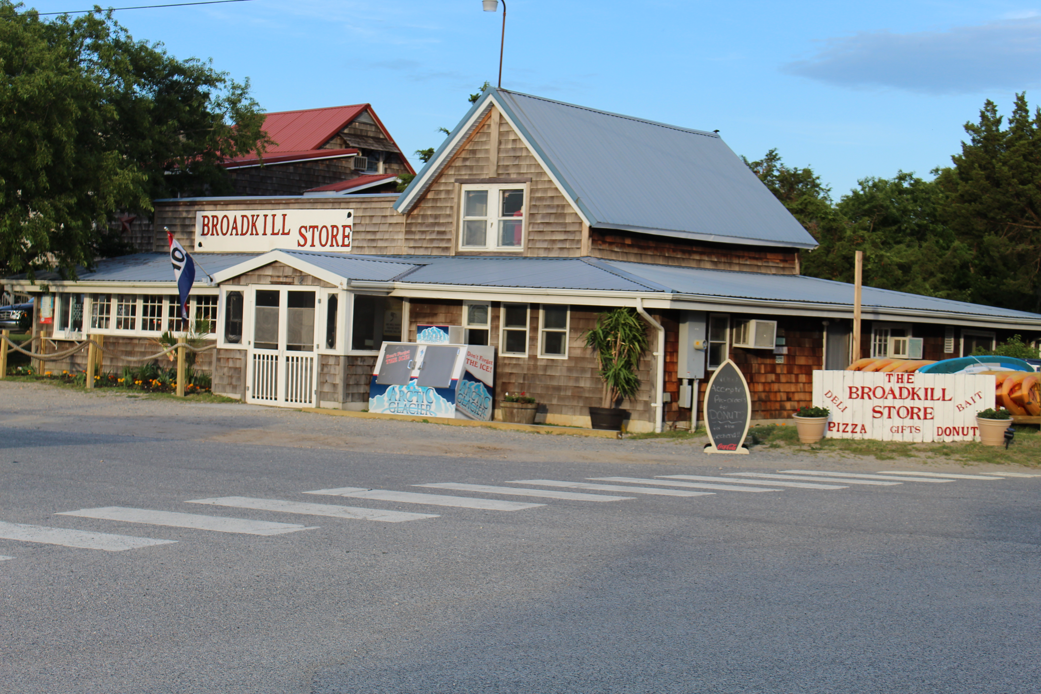

Serving Breakfast, Lunch & Dinner
For Information about Hours Call 1-302-684-4809
Or Visit
The Broadkill Store.com For current information



Coffee bar, donuts, breakfast sandwiches, sticky buns, hot and cold lunch options, pizza, ice cream, and much much more! We are your one stop shop for all your needs!


Follow us on Facebook and Instagram
The Broadkill Store
Add us on Snapchat: broadkill_store

Breakfast
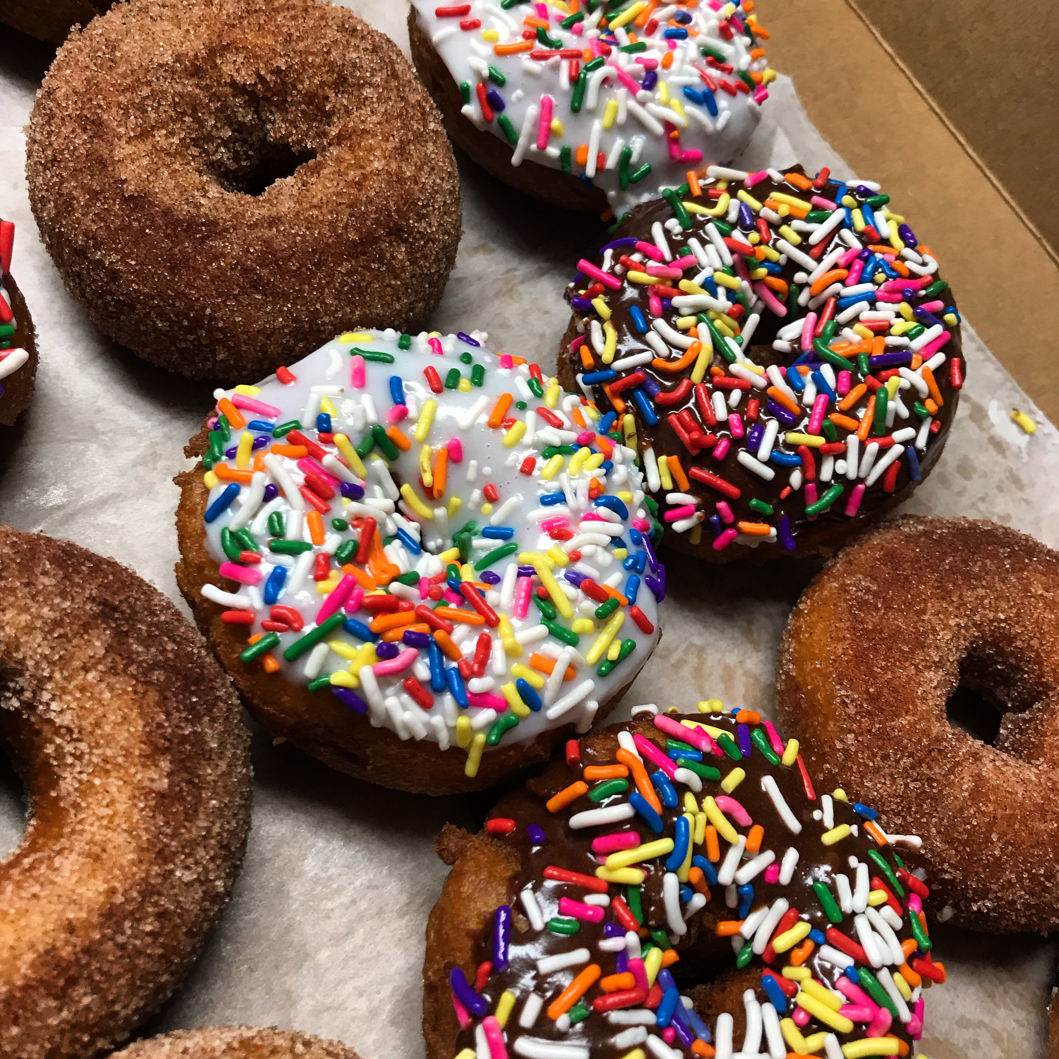
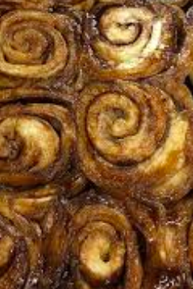

 | Ea. | ½ Dz. | Dozen
Donuts | 2.00 | 9.50 | 18.00
Sticky Buns | 5.25
Muffin | 4.25
Cinnamon Rolls | 4.50
Butter Crumb Cake | 3.25

Donuts are weekends only from Memorial Day to Labor Day. We recommend pre-ordering your donuts due to high demand.
Sandwiches
served on your choice of bread white, wheat, or rye, English muffin, or Bagel (2.25)
Bagel | 3.75
Add butter or cream cheese | 4.50
Egg & Cheese | 6.25
Add Bacon, Sausage, Ham, or Scrapple | 7.75

Sub / Sandwich
Small | 10.90 | Large | 13.50
All Subs: Lettuce, Tomato, Onion, Pickle
Mayonnaise, Mustard, Oil, Vinegar, Sweet Peppers & Hot Peppers available upon request.
Italian
Salami, capicola, ham, provolone cheese
Cold Cut
Salami, ham, bologna, American Cheese
Cheese
Provolone / American cheese or combination
HAM
Ham, provolone cheese
Tuna Salad
Tuna salad, provolone cheese
Chicken Salad
Chicken salad, provolone cheese
Sandwich
BLT |  | 10.25
Crispy Bacon, Lettuce, Tomato, Mayo
BLT Club |  | 14.95
Ham or Turkey, American, Crispy Bacon, Lettuce, Tomato, Mayo
Turkey |  | 9.50
Ham |  | 9.50
Tuna Salad |  | 9.95
Chicken Salad |  | 9.95
Egg Salad |  | 9.95
Prices Subject to change

Hot Sandwiches

Small | 13.75 |  |  |  | Large | 15.75
Cheesesteak
Chicken Cheesesteak
Cheeseburger |  | 10.75
1/4 lbs. all beef hamburger with cheese, lettuce, tomato, onion, and pickles
Double Cheeseburger |  |  |  | 13.75
All Beef Hot Dog 1/4lbs |  |  |  |  | 4.99
Grilled Cheese |  |  | 9.50
Grilled Ham & Cheese |  |  | 10.50
Fried Chicken Sandwich |  |  | 11.00
Salads
Caesar Salad |  |  |  |  | 9.00
Add Chicken |  |  |  |  | 13.50
Chicken Salad scoop |  |  |  |  | MKT
Tuna Salad scoop |  |  |  |  | MKT
Shrimp Salad scoop |  |  |  |  | MKT
Egg Salad scoop |  |  | MKT

